Report Week 9

Achievements:
Parallelism achieved:
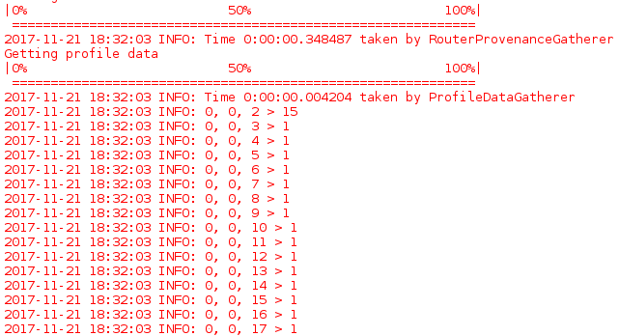
The leader (core 0,0,2) sends an integer with value 1 to all other cores at the same time, and all of those cores return the integer back to the leader simultaneously. Then, the leader takes all of those returned integers and adds them up before returning the result to the host.
Here, the communication structure looks as follows:

--------–---------------–------------------ [02]------------–---------------–--------------
| | | | | | | | | | | | | | |
[03] [04] [05] [06] [07] [08] [09] [10] [11] [12] [13] [14] [15] [16] [17]

Considering problems of scalability
The next logical steps in building the database would be:
1. implementing the previously discussed histogram functioning
2. connecting several chips

In theory, implementing point 1 and 2 is easily doable with the current results. Unfortunately, there are several problems with scalability; for instance unique identifiers for every entry within SDRAM can only take up to 64Kbytes of TCM,
which puts a limit on the number of entries that can be managed by the cores using this method.
Different issues have to be addressed in the foreseeable future, such as an alternative to using integer Ids, string size management and many more, including the problem of instability that comes with using UDP connections.

